ECOMMERCE DATASET

-P. Abirami Soundharya
Data Analytic Oct Batch 2025
INDEX
1 | INTRODUCTION
2 | DATA DESCRIPTION AND PREPARATION
3 | FORMULA AND CALCULATION
4 | PIVOT TABLE
5 | SLICER AND PIVOT CHART
6 | WHAT-IF ANALYSI AND GOAL SEEK
7 | DASHBOARD
8 | MACRO AND POWERY QUERY
9 | INSIGHTS AND RECOMMENDATIONS
10 | CONCLUSION

INTRODUCTION
E-commerce (electronic commerce) refers to commercial activities including the electronic buying or selling products and services which are conducted on online platforms or over the Internet.
Types of E-commerce
E-commerce companies can operate using several different business models.
BUSINESS-TO-CONSUMER (B2C)
B2C e-commerce companies sell directly to the product's end-user instead of distributing goods through an intermediary such as another retailer.
BUSINESS-TO-BUSINESS (B2B)
Similar to B2C, an e-commerce business can sell goods to another company. B2B transactions often entail larger quantities, more detailed specifications, and longer lead times. The buyer can also arrange for recurring orders if the purchase is for ongoing manufacturing processes.
BUSINESS-TO-GOVERNMENT (B2G)
Some e-commerce businesses serve as government contractors, providing goods or services to government agencies and other entities. Often these arrangements require bidding on projects though an established procurement process and can involve large quantities of a given item.
CONSUMER-TO-CONSUMER (C2C)
Individuals can sell things to other individuals on their individual websites or through e-commerce platforms that facilitate the process. Examples of the latter include Craigslist, eBay, Etsy, and many others.
CONSUMER-TO-BUSINESS (C2B)
Some platforms allow individuals to more easily engage with companies and offer their services, especially related to short-term contracts, gigs, or freelance opportunities. Upwork is one example.
CONSUMER-TO-GOVERNMENT (C2G)
Although not an e-commerce relationship in the traditional sense, C2G is a way for individuals to interact with government. For example, uploading your federal tax return to the Internal Revenue Service (IRS) website can be considered an e-commerce transaction as it involves an exchange of information. Taxpayers can also pay what they owe or request a refund for the amount they may have overpaid.
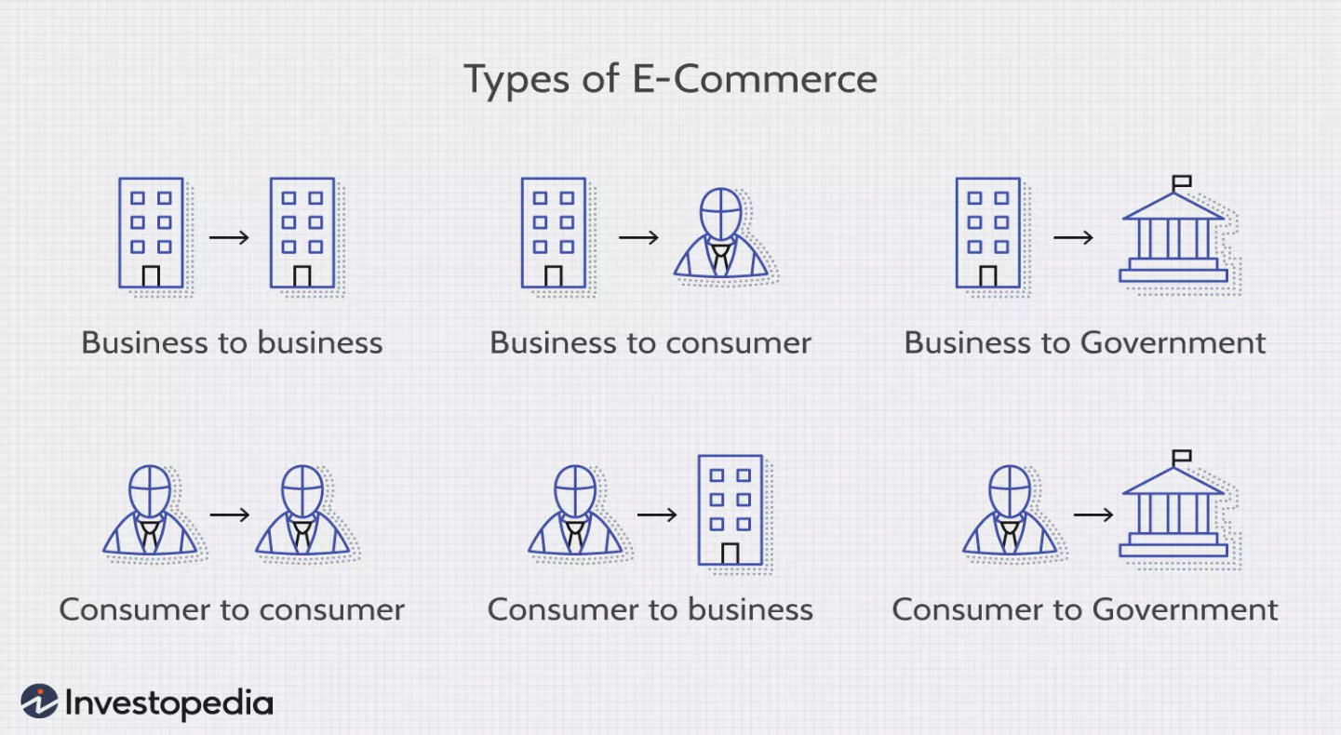

ECOMMERCE DATASET
This dataset contains a collection of fictional e-commerce transaction data created for the purpose of Import, explore, and summarize datasets in Microsoft Excel. Clean data by handling missing values, duplicates and inconsistent entries. Create new derived metrics or calculated columns for deeper analysis. Conduct univariate, bivariate, and multivariate analysis using formulas and PivotTables. Apply What-If Analysis and Goal Seek to simulate scenarios and validate assumptions. Visualize trends and relationships using charts, PivotCharts, and dashboards. Automate repetitive tasks using Macros. Build data models and relationships using Power Pivot for advanced analysis. Document workflow, insights, and recommendations in a professional format.. It includes various e-commerce transaction attributes such as product categories, prices, discounts, payment methods, and purchase dates.
COLUMNS
- customer_id → Unique ID for each customer

- first_name, last_name → Customer’s name

- gender, age_group → Demographic info

- signup_date → Date when the customer registered

- country → Customer’s country

- product_id, product_name, category → Product details

- quantity → Number of units purchased

- unit_price → Price per unit of the product

- order_id → Unique order identifier

- order_date → Date when the order was placed

- order_status → Status of the order (Completed, Cancelled, etc.)

- payment_method → Method used for payment (Credit Card, PayPal, etc.)

- rating → Customer’s star rating (1–5) for the product

- review_text → Written review by the customer

- review_id → Unique review identifier

- review_date → Date when review was submitted

ABOUT THIS FILE
Use Cases for Analysis
- Customer demographics analysis (gender, age groups, countries)
- Sales trends by product, category, and time period
- Order and payment method insights
- Review sentiment and rating distribution
DATA URL:
https://www.kaggle.com/datasets/nabihazahid/ecommerce-dataset-for-sql-analysis

FORMULA AND CALCULATION
HLOOKUP:

VLOOKUP:
XLOOKUP:
FUNCTIONS

PIVOT TABLE

AGGREGATED BY COUNTRY, UNIT PRICE, QUANITY, PAYMENT METHOD AND YEAR.
- Country Wise quantity and unit price sold

- Reviews and Rating by County Wise

category | (All)
Sum of rating | Column Labels
Row Labels | average | bad | good | very bad | very good | Grand Total
Australia | 165 | 199 | 126 | 148 | 189 | 827
Brazil | 143 | 146 | 168 | 146 | 205 | 808
Canada | 159 | 114 | 94 | 163 | 151 | 681
China | 155 | 194 | 147 | 163 | 157 | 816
France | 153 | 187 | 134 | 171 | 167 | 812
Germany | 110 | 135 | 137 | 112 | 145 | 639
India | 162 | 161 | 192 | 118 | 162 | 795
Japan | 140 | 132 | 193 | 125 | 157 | 747
UK | 166 | 169 | 101 | 123 | 141 | 700
USA | 102 | 113 | 140 | 152 | 129 | 636
Grand Total | 1455 | 1550 | 1432 | 1421 | 1603 | 7461

- Payment Method
WHAT-IF ANALYSIS AND GOAL SEEK
Using this data set for Scenario Manager I have predicted the quantity and Net Profit.
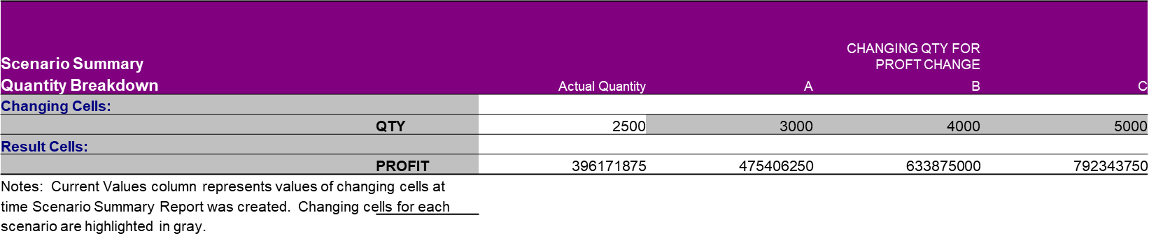
Goal Seek:
Using Goal Seek I have predicted how much quantity sold for certain Net profit.
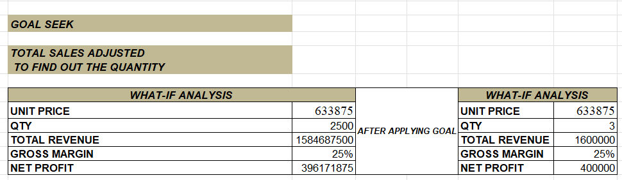
DASHBOARD
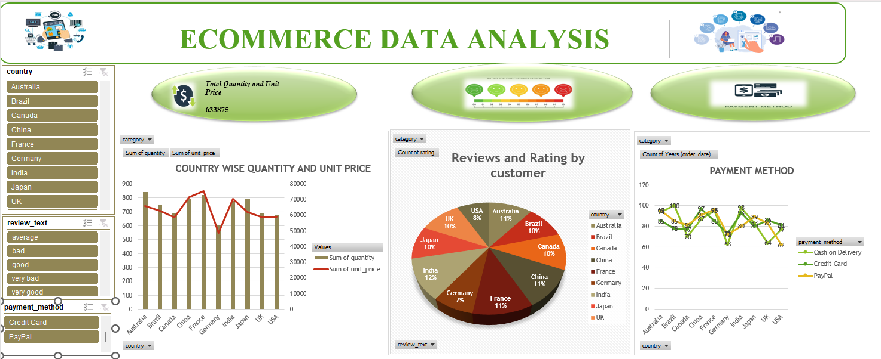
MACRO AND AUTOMATION
Excel macros are a versatile tool that can automate repetitive tasks, saving we time and increasing productivity. Whether we're trying to enable Excel macros, record a macro in Excel, or automate specific actions within our spreadsheet, macros are an invaluable feature.
Using Macro I have done conditional formatting, created table , used KPI’s and data analysis.
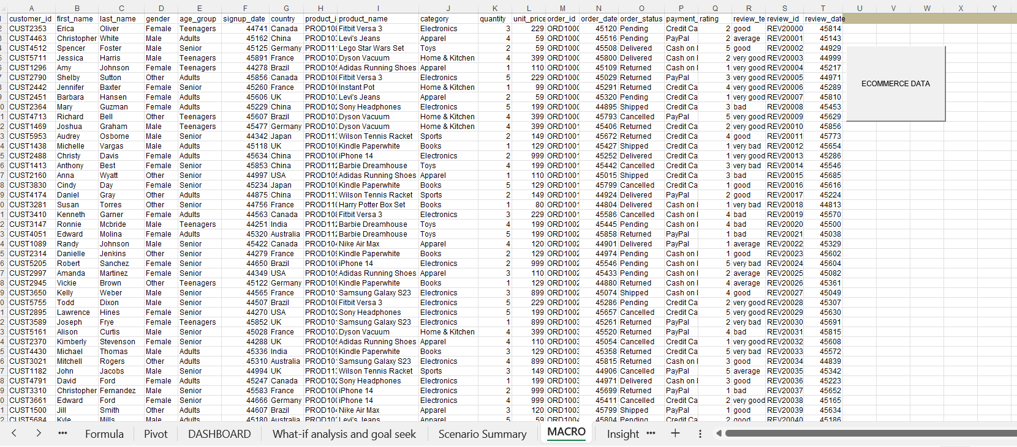
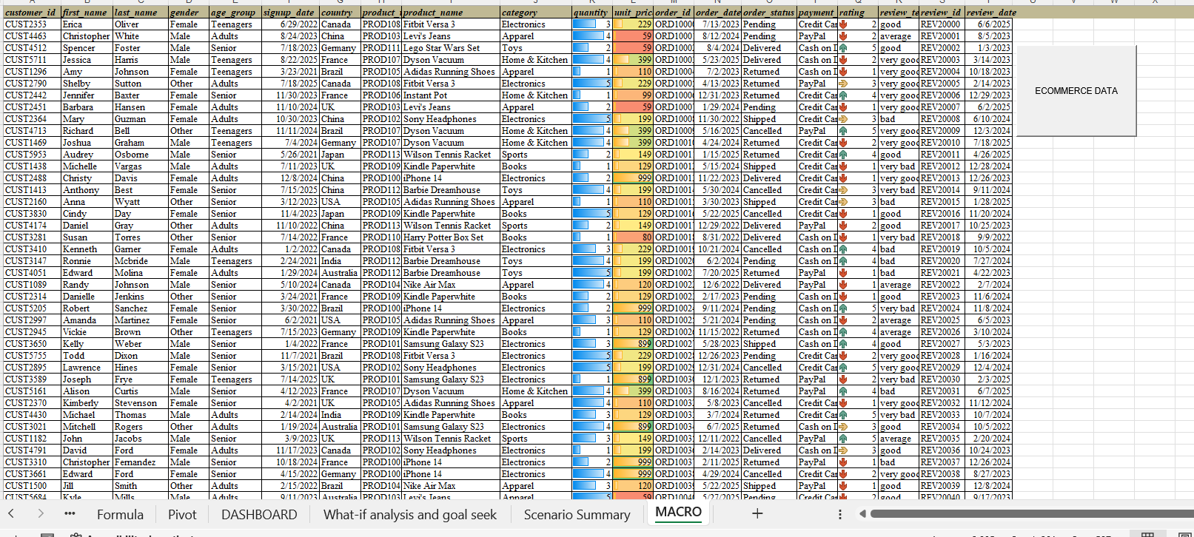

POWERY QUERY
Power Query in Excel is a tool designed to clean, transform, and prepare data for analysis. It allows you to import data from different sources, fix formatting issues, and shape the data exactly how you want it, all without changing the original files.
Power Pivot is an advanced data modeling feature in Excel. Instead of just working with a single flat table, it lets you work with multiple related tables. You can create relationships, use calculated fields, and build powerful pivot tables from huge datasets.

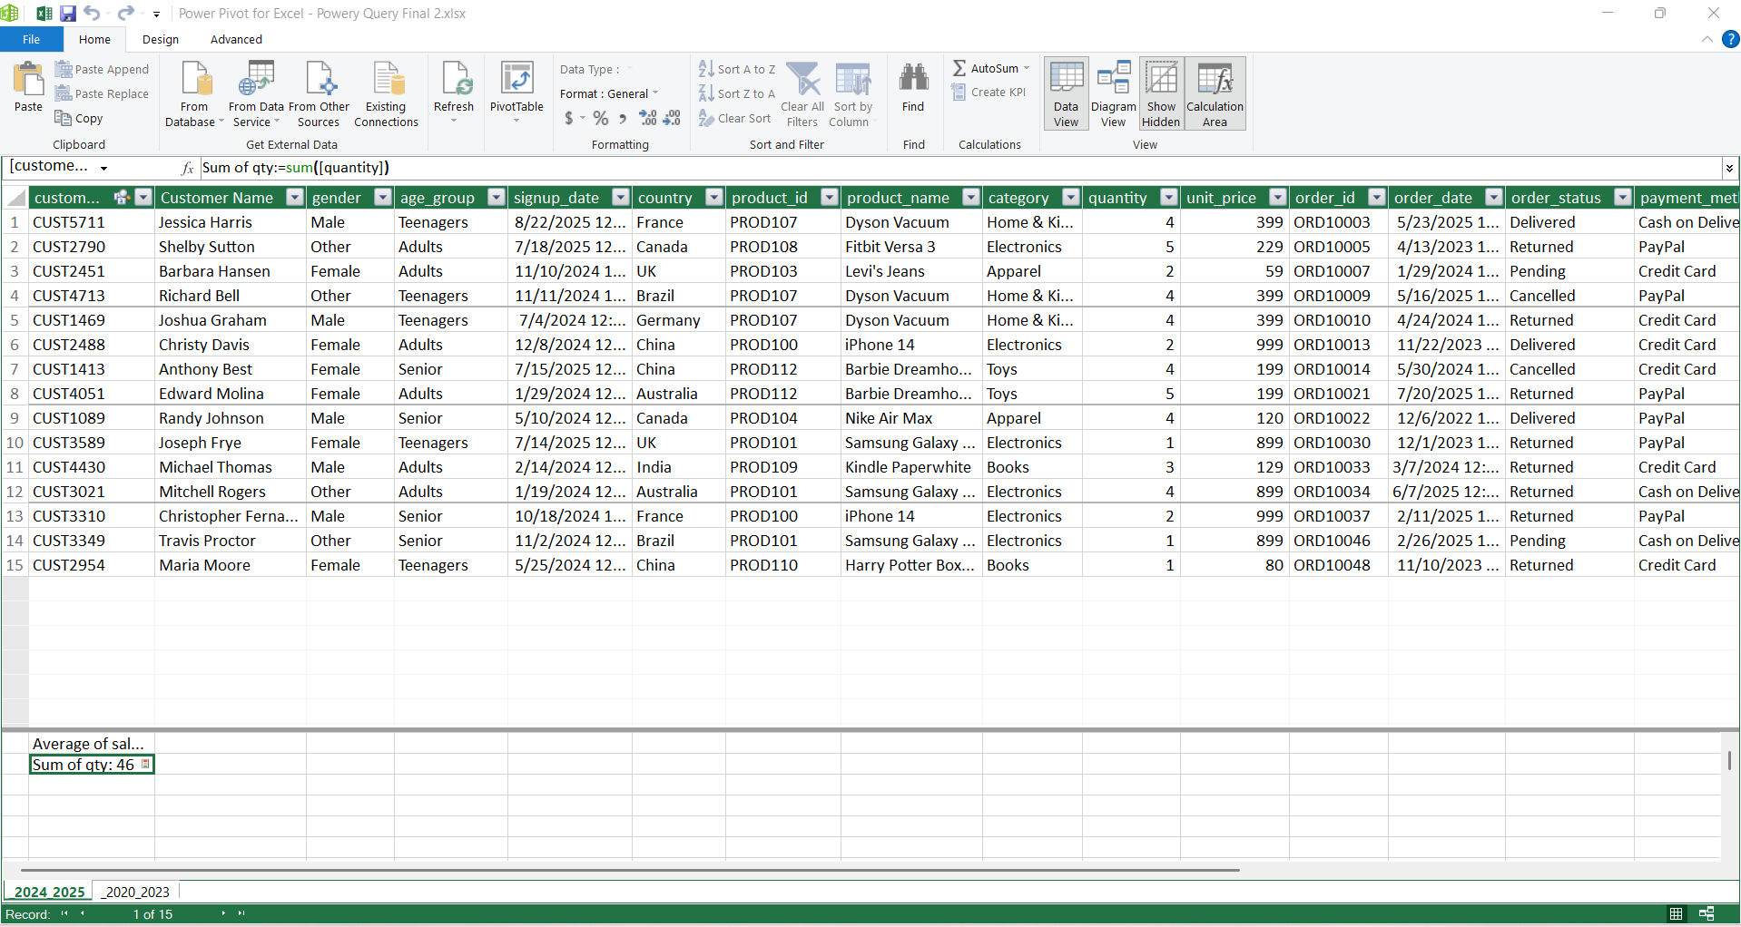

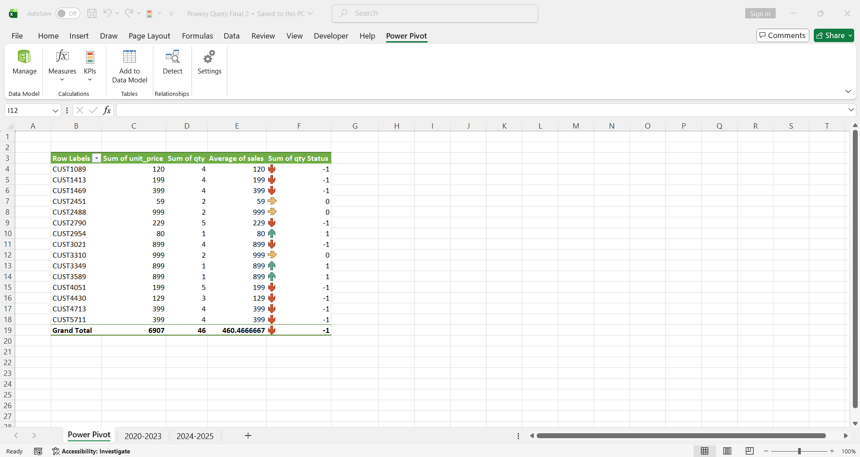

INSIGHTS AND RECOMMENDATIONS
KEY INSIGHTS: YEAR-WISE AND PAYMENT METHOD

The analysis reveals a strong growth period powered by digital payments, while Cash on Delivery (COD) has recently stalled.

- Year-Wise Revenue Trend
Strong Growth to 2024: The business saw consistent and strong growth from 2022 to a peak in 2024.
This confirms successful scaling and market acceptance during this period.

2025 Data: The lower figure for 2025 likely reflects incomplete data for the current year.

2. Payment Method Distribution

Digital Dominance: PayPal and Credit Card are the clear preferred methods, generating the highest total volume.

Essential COD Segment: Cash on Delivery (COD) remains a major channel,

RECOMMENDATIONS

Incentivize Digital: Since Digital Payments are driving all new growth,
introduce targeted incentives (e.g., small discounts, points, free express shipping)
for first-time or repeat customers who switch from COD to Credit Card or PayPal.

Optimize PayPal Experience: Given PayPal's slight lead, ensure its integration is flawless
and promote it heavily,
especially in countries where it is the dominant third-party wallet.

Analyze COD Barriers: Investigate why COD is stagnating. Are local COD fees increasing?
Are digital payment adoption rates rising faster in your core markets?
Use this insight to inform your geographic marketing mix.

Future Planning (Year-wise)

Resource Allocation: Allocate resources disproportionately to digital marketing and high-quality
product sourcing, as these factors seem directly linked to the most successful segment of the business
(high-AOV digital customers in the rapidly growing years of 2023 and 2024).

Operational Focus: Mitigate COD Risk

Prioritize COD Risk Reduction: The previously identified high return/cancellation rate
is often most severe with COD orders.
Since the COD segment is not growing,
focus efforts on reducing the failure rate rather than chasing more COD volume.

CONCLUSION

The analysis of the E-commerce dataset reveals a business in a strong growth phase, primarily driven by the successful adoption of digital payment methods (Credit Card and PayPal) in the years leading up to 2024.

Key Takeaways
- Digital Dominance: PayPal and Credit Card are the preferred and most successful payment methods, generating the highest transaction volume and powering the business's consistent growth.
- Stagnant COD Segment: While Cash on Delivery (COD) remains an essential segment, its growth has recently stalled, suggesting a shift in customer preference or potential market saturation in this channe.
- Successful Scaling: Strong and consistent revenue growth was observed from 2022 to a peak in 2024, confirming successful scaling, market acceptance, and effective resource allocation during that period.

Path Forward
To maintain and accelerate this positive trajectory, the business should prioritize incentivizing the shift to digital payments and optimizing that customer experience.

